Please Save Underwood Avenue Bushland or Carnaby’s Cockatoos Will Die!

Dear Mr Garrett,
I am aware that you are considering the proposal put by the University of WA to subdivide the Underwood Avenue Bushland.

I am deeply concerned that the group of up to 600 Carnaby’s Cockatoos which use Underwood Avenue Bushland will starve if the proposal for housing and further unspecified development in the odour buffer area is allowed to proceed because:
- Food and possible future nesting places will be destroyed

- The suggested offset of woodland 60 kilometres away is worthless for this group of cockatoos.

- The offer to plant trees is on land that has no security of tenure, and it will take decades for the trees to mature to the point where they provide food and habitat to Carnaby's Cockatoos.

Every approval for bushland clearing in the Perth metropolitan area brings Carnaby's Cockatoos closer to extinction! Please do not approve this UWA proposal.

Name: ……………………………………….
Address: ………………………………..........
.……………………………………….

Please Save Underwood Avenue Bushland or Carnaby’s Cockatoos Will Die!

Dear Mr Garrett,
I am aware that you are considering the proposal put by the University of WA to subdivide the Underwood Avenue Bushland.

I am deeply concerned that the group of up to 600 Carnaby’s Cockatoos which use Underwood Avenue Bushland will starve if the proposal for housing and further unspecified development in the odour buffer area is allowed to proceed because:
- Food and possible future nesting places will be destroyed.

- The suggested offset of woodland 60 kilometres away is worthless for this group of cockatoos.

- The offer to plant trees is on land that has no security of tenure, and it will take decades for the trees to mature to the point where they provide food and habitat to Carnaby's Cockatoos.

Every approval for bushland clearing in the Perth metropolitan area brings Carnaby's Cockatoos closer to extinction! Please do not approve this UWA proposal.

Name: ……………………………………….
Address: ………………………………..........
.……………………………………….
To: Peter Garrett, Minister for the Environment
PO Box 6022 House of Representatives,
Parliament House,
CANBERRA 2600
Email: peter.garrett.mp@aph.gov.au

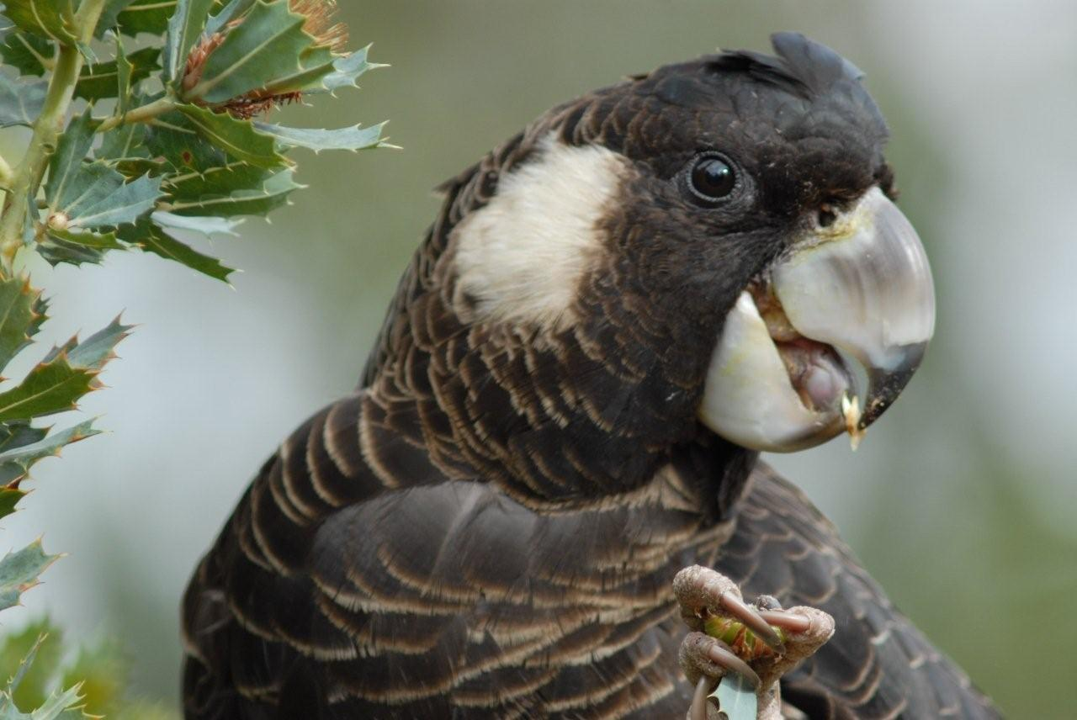
Photo: Tony Kirkby 2008

To: Peter Garrett, Minister for the Environment
PO Box 6022 House of Representatives,
Parliament House,
CANBERRA 2600
Email: peter.garrett.mp@aph.gov.au

Photo: Tony Kirkby 2008

